Midterm Design Report
EGR 313 - Fall 2025
V Venom
Team 5
Majed Alharbi, Mason Benvenuto, Ethan Diedricks, Varun D Nair
Ira A. Fulton Schools of Engineering, Arizona State University

Abstract: This report will go into the design and fabrication process of the web shooters we are building. The overall design of our project has taken on different forms throughout the semester and the current and final design production recently was completed. Our design uses a pre-made refillable cartridge that will be filled with a web-like fluid that is pressurized to be shot about 4 meters away. This report will go over the final design of our project, along with visuals of the first completed mechanical assembly prototype. Finally, the report will include challenges, design iterations and our current progress for the final deliverable.

NOMENCLATURE
F = Force m = Mass
g = Gravitational acceleration = 9.81 m/s² V_{out} - Exit velocity of the fluid (m/s)
h = Elevation P_{in} - Inlet Pressure
P_{out} - Downstream or Exit pressure $ρ$ - Fluid density (kg/m³)

- Introduction

This project focuses on the design and development of a wrist-mounted web-shooting device, inspired by the fictional technology of Spiderman. The aim is to engineer a compact, safe, and reusable prototype capable of deploying a synthetic web-like material at high velocity through the integration of fluid mechanics, materials engineering, and mechanical design.
The main objectives are:
- To design a small wrist-mounted launching mechanism.
- To develop a polymer-based web fluid with adequate strength and adhesion.
- To create a reliable trigger system for controlled deployment.
- To ensure safety and repeatability during operation. An additional goal is to evaluate the tensile strength of the web for possible object retrieval.
The technical scope of the project includes the formulation of web fluid using chemicals, adhesive and water, combined with the use of pressurized CO₂ canisters as the driving mechanism. The project integrates mechanical design of the launcher, experimental material development, and iterative testing to ensure functionality and safety.
In summary, this work demonstrates how creative design and engineering principles can be applied to transform a fictional concept into a functional prototype while addressing practical constraints and technical feasibility.
- Project Details and Plans
2a. Project Schedule
The project schedule is stretched within 16 weeks (one semester), August 24th- December 7th. The team is expected to follow both the timeline of assignments to turn in, and to follow the timeline of designing and construction of the project.
Table 1: Table for canvas assignments (zoom in required)
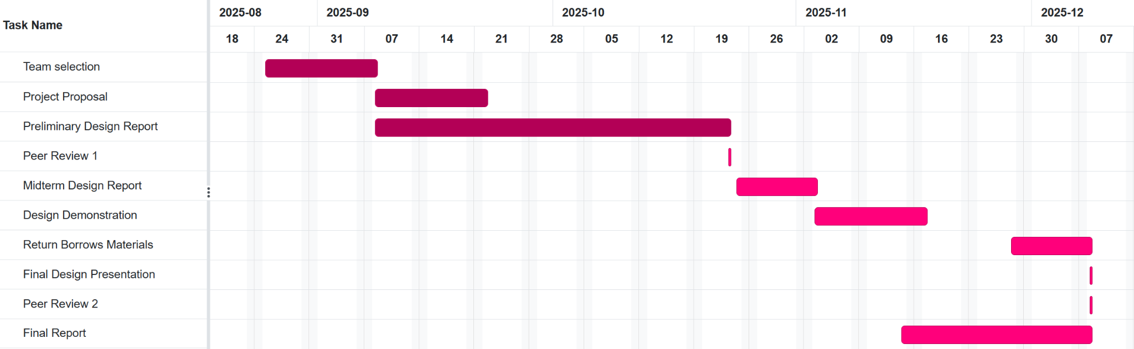
Table 2: Table for Timeline of project Creation (zoom in required)
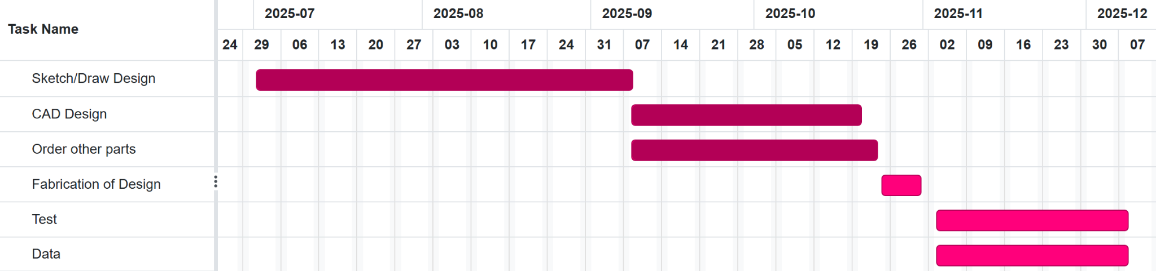

Figure 1: Original Sketch of system
2c. Detail of main body
The main body of the Web Shooter serves as the central structural component that houses and supports all the primary subsystems of the device, including the CO₂ canister chamber, fluid reservoir, nozzle interface, and trigger mount. It acts as both a pressure containment shell and a mechanical frame that connects to the wrist guard and trigger mechanism.
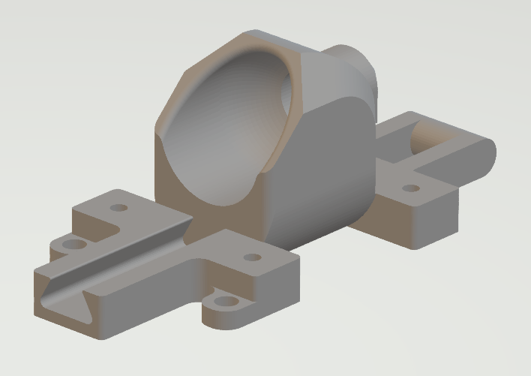
Figure 1: CAD Model of Main Body
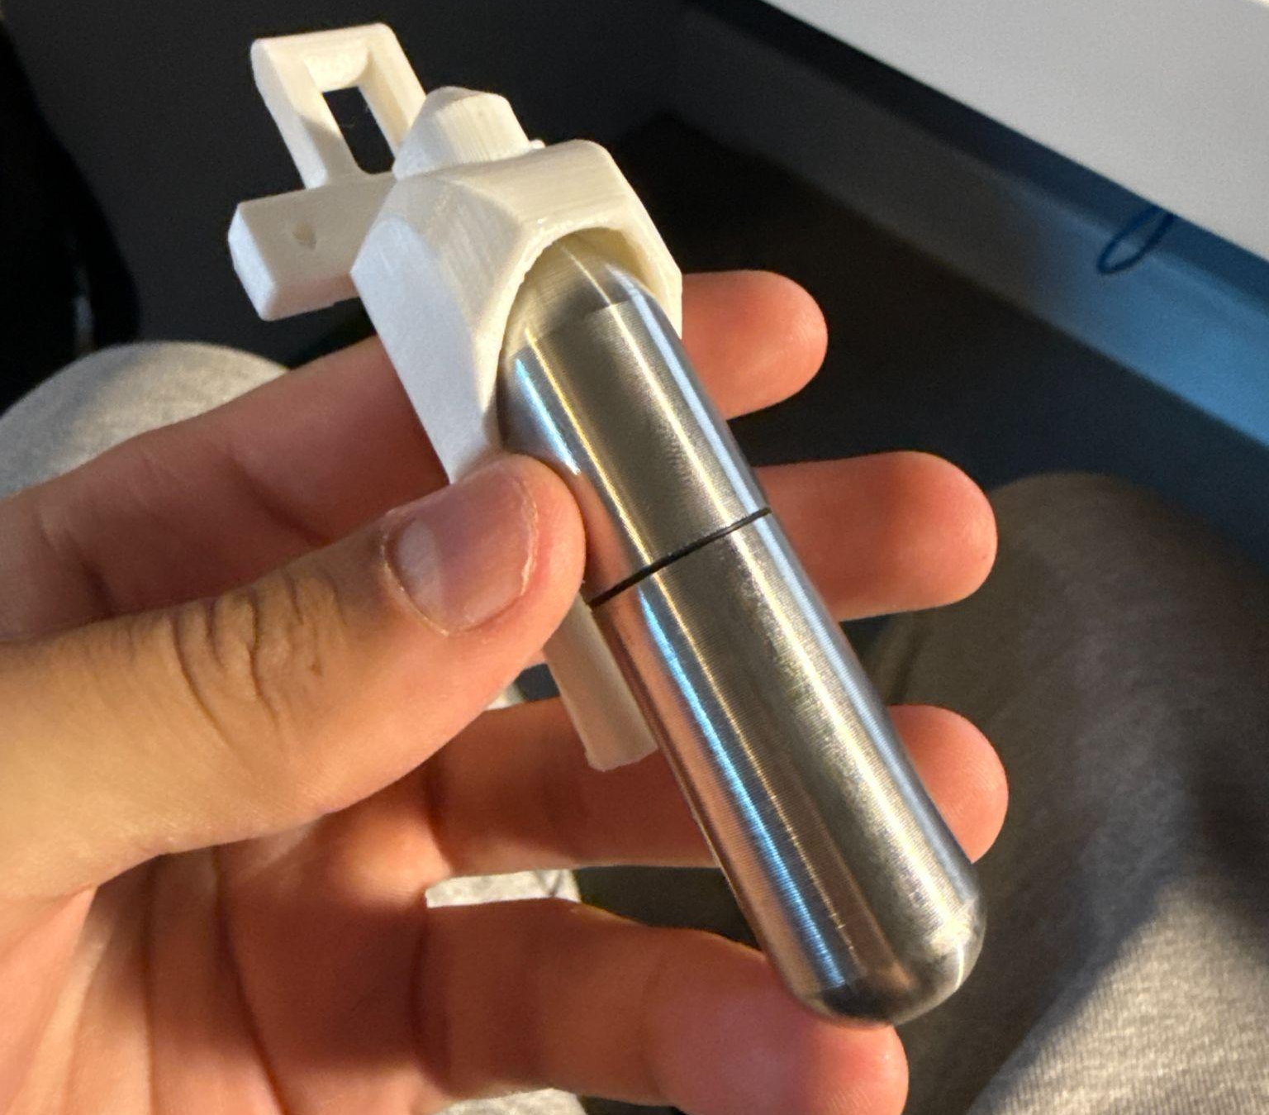
Figure 2: 3D Printed Main Body
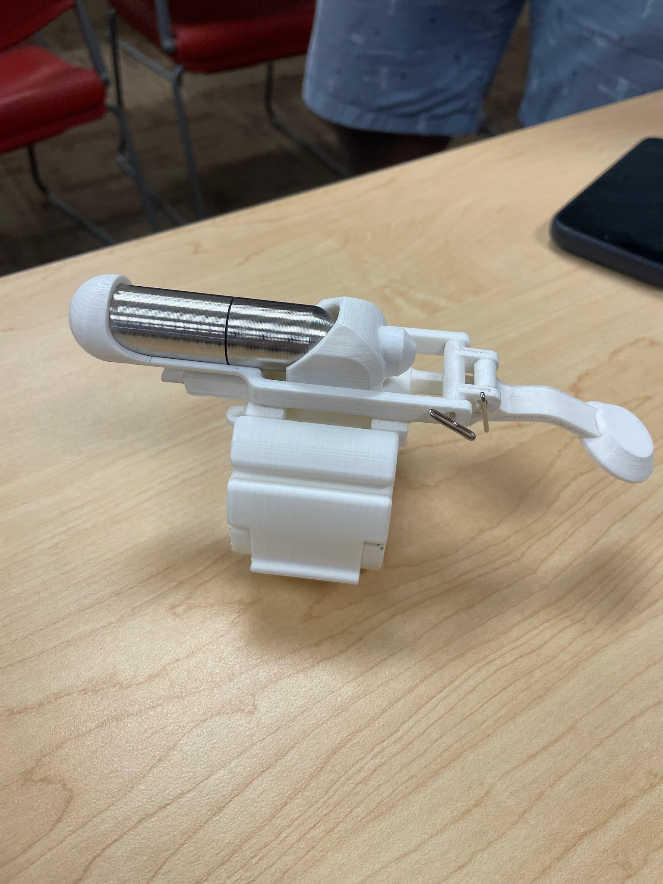
Figure 3: Full web shooter MK. 1
2c. Description of Mechanical system
The mechanical system of the Web Shooter uses a two part sliding mechanism built into the two main body designs. The front half of the main body has a base with a triangular cutout to connect the front body and rear body. The rear body is designed with the exact opposite triangular extrusion to allow for a simple and clean, semi permanent connection. The adjoining pieces were designed to fit in a near friction fit way while allowing the rear body to slide in the axial direction both forward and backwards.
The trigger mechanism is essentially a see-saw type design, which simply uses an axle and a curved piece to unify the force from the button being pressed and deliver the pulling force to the rear body to slide. As this force pulls the rear body forward, this compresses the valve that is built into the canister, opening it and allowing the pressurized fluid to exit out of the nozzle. The canister connection to the nozzle without any extra o-rings didn’t have a tight seal, so simply adding in a new o-ring created a tight seal between the canister and the frontal main body.

3. Design and Analysis
3a. Specific design -
The prototype assembly has 7 individual components. The components consist of 2 bracelet pieces, 1 circular button, 1 lever arm, 1 joint connection, 1 housing/nozzle body piece, and 1 housing and sliding piece. The design to CAD model was the most challenging and time consuming stage of the process. The goal was to design for reusability while also keeping the component count down. As this was the goal, each component is extremely important to the design's functionality. The main challenge arose from the trigger mechanism, as this needed to use the downward force of the human finger pressing on it and translate that into axial force to press the canister and open the valve.
Before manufacturing, we were unsure of whether the force that the valve exerts to stay closed would be enough to push the sliding mechanism back into the resting position. This was the main reason that we rushed the prototype creation process. Fortunately for us, after sanding down the triangular extrusion, the sliding mechanism’s friction was less than the force of the valve… So it worked!

The project centers on a wrist-mounted web-shooting device composed of three main subsystems: the pressurized CO₂ canister, the fluid reservoir, and the nozzle–trigger mechanism. The canister provides the driving pressure, the reservoir holds the polymer-based web fluid, and the nozzle is designed to eject the fluid in a narrow, high-velocity stream. The trigger mechanism regulates flow, ensuring controlled deployment from a compact and wearable assembly.

Analytical Considerations -
The design requires analysis of several engineering factors:
- Fluid Dynamics: Pressure–velocity relationships are applied to estimate the exit speed of the web fluid. The nozzle diameter and fluid viscosity play a critical role in determining spray pattern and range.
- Material Properties: The web fluid—prepared from acetone, ethanol, PMMA powder, polyvinyl acetate, and water—must be tested for adhesion, viscosity, and setting time to ensure effective web formation.
- Structural Integrity: The wrist-mounted housing must be capable of withstanding repeated CO₂ pressurization without leakage or deformation.

3b. Fabrication Progress
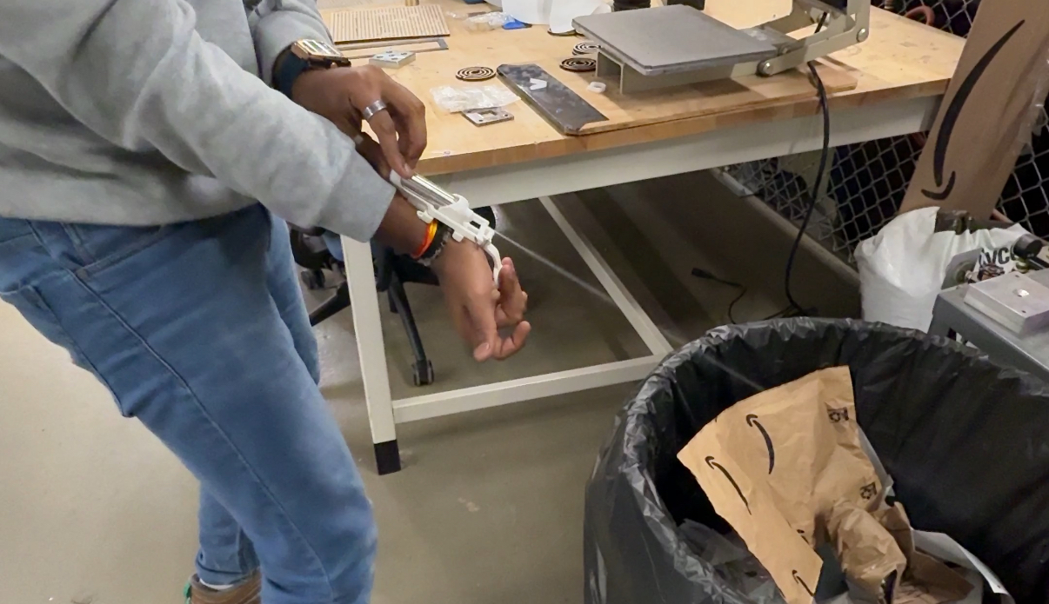
Using the refillable canister’s dimensions, we were able to design the mechanical housing and trigger mechanism and 3D print our prototype.
The team has successfully finished the design of the system and finalized the mechanical components. With all 3D printed parts prepared, CO2 refillable canister, trigger system and the wrist guard the mechanical assembly is fully developed.

Now that the mechanical and design fabrication is complete the team has shifted all its effort towards testing the chemical component. The phase will focus on performance, safety and reaction behavior of the chemical formulation. Testing will include collecting data, observing the reaction's outcome and making any needed changes to make sure that it has consistent activation.

Regular team meetings will happen twice a week to verify that chemical testing will align with the complete design and confirms the overall design safety and effectiveness.
3c. Testing Design

After fabrication, the team will conduct testing at the designated field south of the Red Lot at Arizona State University. Testing will take place on a calm, wind-free day to ensure consistent and accurate results. Multiple trials will be performed to evaluate key performance factors, including shot distance, trigger response time, adhesive strength, projectile accuracy, and reload efficiency. Each test will be repeated four times, with all team members participating to ensure reliable and comprehensive data collection.

3d. Validation

To Validate the performance of the Web Shooter, Bernoulli’s equation was applied to analyze the pressure velocity relationship with the CO₂ Powered nozzle system. By assuming incompressible flow and negligible elevation change, Bernoulli’s principle relates the static pressure within the CO₂ canister to the dynamic pressure and velocity of the exiting fluid through the nozzle

P_{in} + ½ pV_{in}² = P_{out} + ½ pV_{out}²

This relationship validates that in case an internal pressure directly increases the kinetic energy of the exiting fluid, resulting in higher launch velocity and range. Experimental testing of shot distance and fluid deployment confirmed this theoretical prediction, as higher CO₂ canister pressures produced consistent increases in exit speed and projectile distance. Therefore, Bernoulli's base analysis effectively supports the operational design and expected performance of the system.

4. Potential Challenges/Bottlenecks

The design that we have decided to build comes with a wide array of potential challenges. The main concern for our group currently, is the trigger mechanism for each design.

Materials:
- Acetone
- Ethanol
- Polymethyl Methacylate Powder (PMMA Powder)
- Water
- Polyvinyl Acetate
- CO₂ Canisters

Functional Requirements:
- Must shoot a tethered web projectile at a velocity sufficient to reach 4 meters
- Must be activated via a hand gesture or push button control
- Must be safe for indoor demonstration (non lethal, non toxic)
- Should allow a reload mechanism in order to shoot more webs
Potential system components
- Housing: 3D-printed ABS causing shape to fit forearm
- Launch Mechanism: Modified spring based plunger or mechanical lever
- Power source: C02 shot powered.
- Trigger system: Flex sensor or push-button on palm of hand
- Control unit: Arduino Nano for control
- Safety features: Pressure relief with lever.

5. Conclusion

The preliminary design of the CO₂ powered wrist mounted web shooter successfully integrates concepts from fluid mechanics, material science, and mechanical design to create a functional and safe prototype. Through the application of Bernoulli’s equation, the team validated that the nozzle geometry and pressure system can theoretically achieve the desired fluid exit velocity to propel the web up to the target range of four meters. The use of refillable CO₂ canisters provides a sustainable and reusable energy source, while the 3D printed housing ensures lightweight wearability and durability.

Future work will involve optimizing the nozzle design to reduce energy losses, refining the web fluid mixture for improved adhesion and strength, and integrating electronic trigger controls for enhanced responsiveness. Overall, the project demonstrates a strong foundation in engineering principles and creative problem solving.

6. Appendix

Total cost for the prototype is 80$-90$ with the cartridges and the chemicals as the major expenses.

Table 3: Bill of Materials
Qty | Item # or Quote # | Direct Website Link to Product | General Description of Item | Business Purpose/Benefit for the Purchase | Unit Price | Line Total
1 | UL00091 | https://www.ultraforceairsoft.com/product-page/ultraforce-12g-refillable-cartridge | refillable co2 canister | Gas Delivery mechanism for our web fluid | $15.00 | $15.00
1 | B01LYNUFSX | https://www.amazon.com/iit-91000-Butane-Pencil-Torch/dp/B01LYNUFSX/ref=sr_1_58?crid=2JQGXOM7RDG1Q&dib=eyJ2IjoiMSJ9.k-QkYwjVouiZXAAgjHT8qldXTSQcQWGuf6uc8AfJyNswpZjC3vgcCqoLnrw3xegPyEJ7fQS_64IhM51L07VogPyqHIa6USb_IibnJRn0arIi5mCaJnPuBMUd88bct3WksxAvg1EjwojvXZxv2EVuKq-CLKnmx9Li3q-azrRnQtrwqfRlJJ9LEluSoQHKvuBq1wUmTAd_vzRPBXXv4zkRZ6-9Auqk2-dzwFqR4UKpD91HWPWeL-UJ2dYrPx-_UKrCsTVzlnbxLEBeX09imSHydsFYKgAJe-TokgzA_2g4Gio.tnSiYJ9xjtxeJv5qB1ZanDUquV4ut-lasOyeCGAHx18&dib_tag=se&keywords=butane+pen&qid=1758058719&sprefix=butane+pen%2Caps%2C195&sr=8-58 | Butane Torch | Gas Delivery mechanism for our web fluid (second test) | $9.49 | $9.49
1 | B0DVSS196D | https://a.co/d/3Lvr5nR | Acetone pure | for making wep fluid | 5.98$ | 5.98$
1 | B086Q6QFQS | https://a.co/d/id34Acd | Ethanol | for making wep fluid | 16.59$ | 16.59$
1 | B0DP79TTM4 | https://a.co/d/agGPA03 | Polyvinyl Acetate | for making wep fluid | 8.49$ | 8.49$
1 | B071KXLG65 | https://www.amazon.com/Mia-Secret-Acrylic-Powder-Professional/dp/B071KXLG65/ref=sr_1_3?crid=376WQZ8ZBHXYG&dib=eyJ2IjoiMSJ9.nobrQqI8jmXE-kc_VC14RNE0_Q8L-bLGbzLvUxfMp1DtIMYMLZscKQWn9u4teAC5jE0Pg805CAxaFHDVuMHrVPGqVnrnc1-P65rWRHo_9hJ7z1Wd4pshbojl_I9dJOM9HXeXk397o66HpXeXgIceAuRQZiGcShbBraNbVE2irIOhulol-MZmACpmUruBFeBH3GEYrXWuPyugtxcN6ZSeV1yKyuBtMpzldIw7SFZBH88.BnmcWR2GGzTQeuUhm_zz1daOTbZX9N_2FCQhpa-g9qo&dib_tag=se&keywords=pmma+powder&qid=1759264860&sprefix=pmma+powder%2Caps%2C151&sr=8-3 | PMMA Powder | for making web fluid | $8.50 | $8.50
1 | B091DP68C8 | https://www.amazon.com/CXWXC-Threaded-Cartridges-Bike-Tires/dp/B091DP68C8/ref=sr_1_5?crid=3FN8TZFTS803&dib=eyJ2IjoiMSJ9.HXaYRe7fLKHkC_h-3tpCbgBhszcpn0PVaJWc_bkOC9VptiUQa-EPDVlnkx8ZbhxI9zwrSCGlULEd1D_kUNdB8c4UE2hyDtEKU9bnCghN3DFeMmIutKmdtSJFW4Df8gLBgGxQyVPYuQQ5z9Uzb0efAaAisRVubM8Y-CrbTIrl5pS8aHUfwxLRlbWR4z-657dCegiHI40WSkZ6BmEQmEStoyywIy6Meds47tXBydh1GOS9oFQLNlIztT-6yenp-aQH79si5NVyJqqldx6Vu3a5ZsPmxDTPzctRw2YTiN6KgjQ.hewnlH5DMxoL1e6pR5j_5qfZVrSzRtCGJuGqzrb971Y&dib_tag=se&keywords=threaded+co2+cartridge&qid=1759267090&sprefix=threaded+co2+catridg%2Caps%2C152&sr=8-5 | threaded co2 cartridges | trigger mechanisms | $ 19.990 | 19.99
1 | B0C5C8BR99 | https://www.amazon.com/Ctrepower-CO2-Inflator-Bike-Tires/dp/B0C5C8BR99/ref=sr_1_13?dib=eyJ2IjoiMSJ9.mz4OrKTBhG9SruEYUiwVWpa8mJlTm_Mw-BGg6i5ZxVbZ8C0c5Vs9eO0GBvM3pRAd-6DRs2LJGq6s5nUBfcDquRmdhKLyNV2cROqm-qOa8Cm66fSLJxa1VlnJTIdeWQnjZrtdal3vOFMEoJ681CAFlbuA3c9VF22QV_eQlqUy4qKvdOfHx3-cQ9iI2I5Or3tEvT3ouXdMhT4OhINVMsAyKf8reLLq46S7xi4YfCsw6x8RQAfnInwS6hzxSTPRNQuGkHphdc5dxb6Y5JWVn1JbFvCqX0M3da-OtsK0mUcjXU4.CwJa89nuxKGrPQ1k7_layDdk-YUh0DTCUV0Jtrjp1yQ&dib_tag=se&hvadid=694684910110&hvdev=c&hvexpln=67&hvlocphy=9030039&hvnetw=g&hvocijid=12959869562859363132--&hvqmt=b&hvrand=12959869562859363132&hvtargid=kwd-875900290554&hydadcr=2429_13557917&keywords=co2%2Bcartridge%2Badapter%2Bvalve&mcid=905ee8f3f34a327d898e53244445a20b&qid=1759266094&sr=8-13&th=1 | threaded co2 cartridge valve | trigger mechanisms | $ 13.990 | 13.99

7.References

[1]https://www1.grc.nasa.gov/beginners-guide-to-aeronautics/bernoullis-equation/?
[1]https://en.wikipedia.org/wiki/Discharge_coefficient
[1]https://en.wikipedia.org/wiki/Bernoulli%27s_principle

